E-Justice in Insolvency Law in Korea

Prof. Dr. HO Moon-hyuck

1. **History of Insolvency Proceeding**
2. **Overview of Insolvency Proceedings in Korea**
3. Corporate Rehabilitation
4. Corporate Bankruptcy
5. General Rehabilitation
6. Personal Rehabilitation
7. Personal Bankruptcy
8. **Digitalizing of Proceedings**
9. History
10. Court Network System
11. Case Management System
12. Electronic Case Filing System
13. Electronic Courtrooms
14. **Characteristics of E-justice in the Bankruptcy Court proceedings**
15. Declaration of Credits etc.
16. Meeting of Interested Persons and Creditors

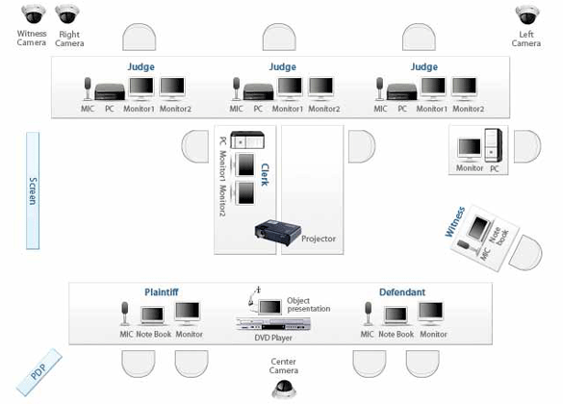

Electronic Courtroom